Practical No. 16
Aim : 4) Write a program to generate following output using Border Layout.

Name : Danish Altaf Solkar | Class : CO - B
Enrolment no. : 24111590805 | Batch : 2

Code :-
import java.awt.*;
public class prac16 {
public static void main(String args[]) {
Frame f = new Frame("BorderLayout Demo");
f.setSize(500, 500);
f.setVisible(true);
f.setLayout(new BorderLayout());
Button north = new Button("North");
Button south = new Button("South");
Button east = new Button("East");
Button west = new Button("West");
Button center = new Button("Center");
f.add(north, BorderLayout.NORTH);
f.add(south, BorderLayout.SOUTH);
f.add(east, BorderLayout.EAST);
f.add(west, BorderLayout.WEST);
f.add(center, BorderLayout.CENTER);
}
}

OUTPUT :-
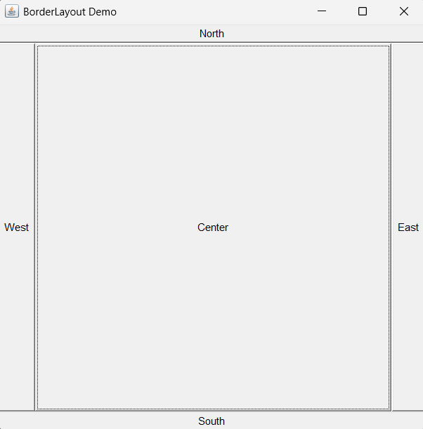

Process related  (35) | Product related  (15) | Total Marks  (50) | Signature

